Computer Language Diagrams

Method Reference in a Diagram
The principle of method reference is explained in the article Method Reference. This article demonstrates the expression of it in a diagram.

A method reference is displayed in a diagram as a square connected to another square.

The diagram below displays an object, that contains a reference to a method.

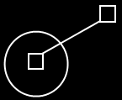

See also: Method Reference

Author & Copyright: Jan-Joost van Zon Date: May 25, 2008 – May 25, 2008 Location: Oosterhout, The Netherlands Status: Finished

